WE CAN’T HELP IF WE CAN’T FIND YOU | - posted address numbers save lives
Address numbers posted at your home are imperative to the services provided for you by the Town of Selma including Fire, EMS, Police, Water, Sewer, Electric, Zoning, and many more.  Numbers Posted on your home are required by Town Ordinance. Numbers must be at least 3” high and contrasting color to the home. Numbers should be visible from the street and reflectivity is highly recommended. Not having numbers posted could lead to a fine but more importantly can delay emergency response to an incident at your home.  Numbers can be purchased at your local home improvement store or by ordering at Selma Town Hall . Ask your customer service representative today.  YOUR SAFETY IS OUR TOP PRIORITY  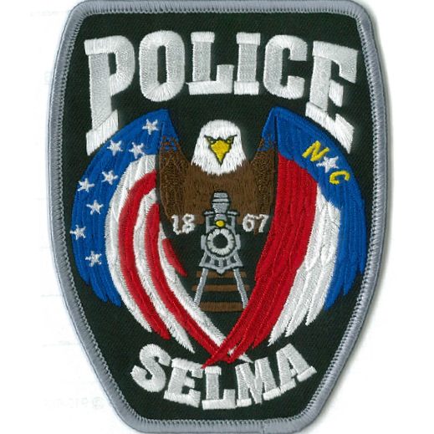 | 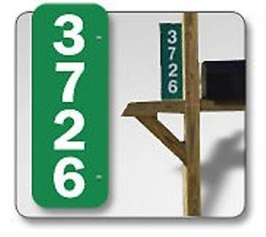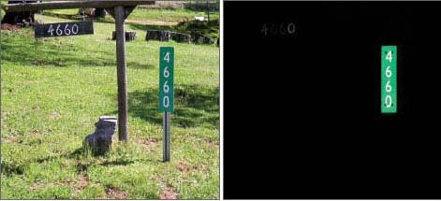  ORDER HERE  NAME__________________________  PHONE_________________________  HOUSE NUMBER________________  VERTICAL ___OR HORIZONTAL___  Green __Red __Blue __  SIGNS ARE $15.00, AND CAN BE PICKED UP AT TOWN HALL 2 WEEKS AFTER ORDER IS PLACED

