Town of Selma - Utilities

Instructions to set up your on-line account

- Go to Selma-nc.com and click on Utilities.

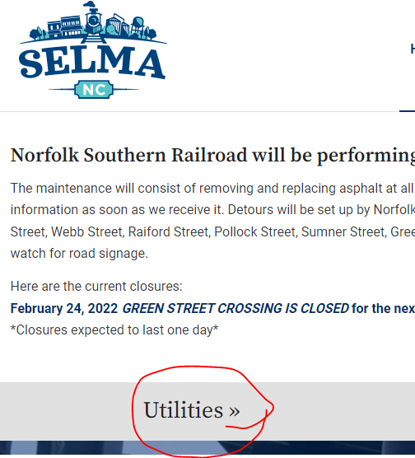

- Click on the button to pay your utility bill.

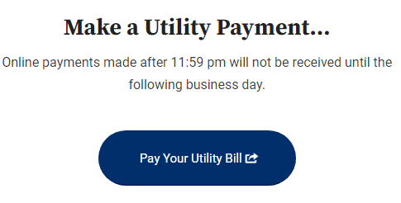

- Click Log In to set up a user account – you will need an email address, your account number, and the last payment amount (this is a one-time request for when you first set up the account).

- An email will be sent to the e-mail address provided confirming the transaction.
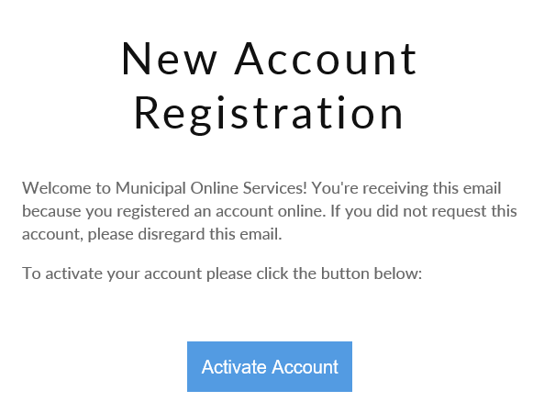

- Log in using your new credentials.

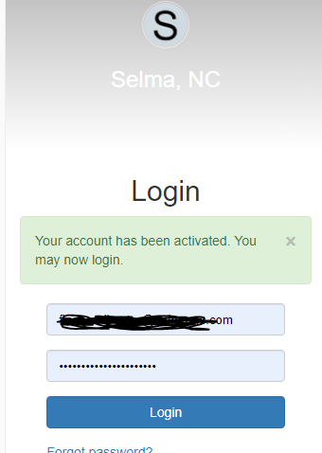

- Click on Utility Billing
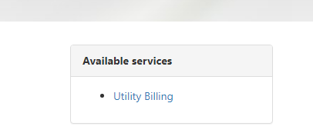

- Click on the account number

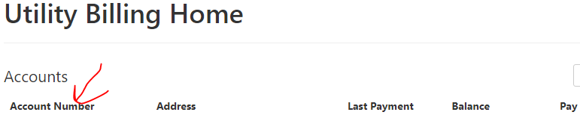

- Use the tabs at the top of the page to switch to what you want to see.
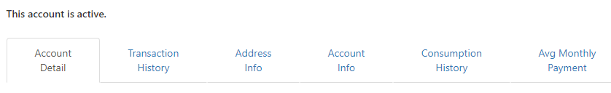
Account Detail = Current Balance
Transaction History = Last twelve months of bill and payment history
Address Info = Street address and meter numbers
Account Info = Non-working tab at this time
Consumption History = Two years of consumption
Avg Monthly Payment = For equal pay customers only

Last updated 2/25/2022

