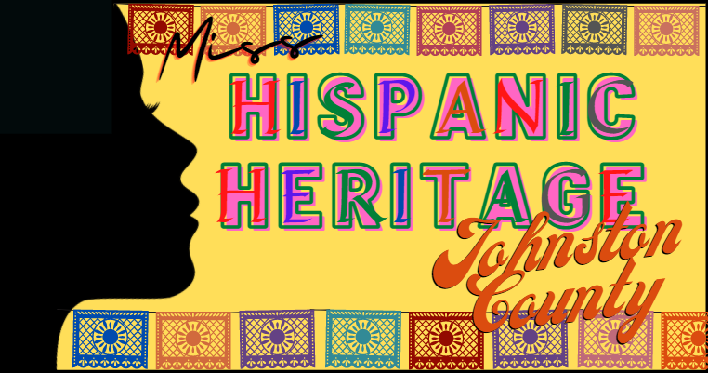
MISS HISPANIC HERITAGE
JOHNSTON COUNTY 2022

COMPLETE EACH SECTION AND RETURN IT WITH THE APPLICATION AND ENTRY FEE.
PLEASE TYPE ALL INFORMATION

CONTESTANT’S FULL NAME: _________________________________________________

AGE: _____ BIRTHDATE: _______________

SCHOOL: ____________________________________________________________________

HONORS: ____________________________________________________________________

HOBBIES: ____________________________________________________________________
FAVORITE T.V. SHOW: ________________ FAVORITE FOOD: __________________

FAVORITE COLOR: ___________________ FAVORITE SONG: __________________

SPECIAL TRAINING (DANCE, MUSIC, ART, ETC.): ______________________________

________________________________________________________________________

________________________________________________________________________

________________________________________________________________________

AMBITION: __________________________________________________________________

______________________________________________________________________________

________________________________________________________________________

NON PROFIT ORGANIZATION REPRESENTING: _____________________
______________________________________________________________________________

PARENTS’ NAMES: __________________________ _______________________________

ADDRESS: _______________________________________________________________
Address City State Zip Code
HOME #: _______________________ CELL #: ______________________________

EMAIL: _________________________________________________________________

SPONSOR NAME: ____________________________________________________________

ADDRESS: _____________________________________________________________
Address City State Zip Code
SPONSOR NAME: _____________________________________________________________

ADDRESS: ____________________________________________________________
Address City State Zip Code
SPONSOR NAME: _____________________________________________________________

ADDRESS: ____________________________________________________________
Address City State Zip Code
SPONSOR NAME: _____________________________________________________________

ADDRESS: ____________________________________________________________
Address City State Zip Code
SPONSOR NAME: _____________________________________________________________

ADDRESS: ____________________________________________________________
Address City State Zip Code
SPONSOR NAME: _____________________________________________________________

ADDRESS: ____________________________________________________________
Address City State Zip Code
SPONSOR NAME: _____________________________________________________________

ADDRESS: ____________________________________________________________
Address City State Zip Code
SPONSOR NAME: _____________________________________________________________

ADDRESS: ____________________________________________________________
Address City State Zip Code

I hereby acknowledge that I have read the official rules and regulations, that I am complying with them in every way, and that the personal data as herein set forth is correct. I understand that registration fees are nonrefundable, and I agree to abide by all the rules of the contest. I further release and agree to not hold the Town of Selma and its agents responsible for any claim arising out of injury resulting from the contest and any activities associated with the contest.

Contest Sponsors: Town of Selma Parks and Recreation Department 919-975-1411 afox@selma-nc.comand Sola Creations 919-351-0120 solacreations@icloud.com
Photography Waiver: Please read and initial the Photography / Social Media Waiver attached. A signed waiver is required to participate.

Non-Discrimination Policy: The Town of Selma prohibits discrimination in all its programs and activities based on race, color, national origin, gender, religion, age, disability, political beliefs, sexual orientation, and marital or family status. (Not all prohibited bases apply to all programs.) Persons with disabilities who require alternative means for communication of program information (Braille, large print, audiotape, etc.) should contact Selma Parks and Recreation Department at (919) 975-1411

______________________ __________ ______________________ __________
Contestant’s Signature Date Parent’s Signature Date

Photo Consent and Release Form

I hereby grant permission to the Miss Hispanic Heritage Johnston County (herein HHJC) to photograph me or otherwise capture my image. I further grant to the HHJC the right to reproduce, use, exhibit, display, or broadcast and distribute these images in any media now known or later developed for promoting, publicizing, explaining, or illustrating the business and/or projects by the HHJC. I understand that I will not be paid for my image to appear in any of the above-mentioned mediums. I also understand I may revoke this authorization at any time by notifying the HHJC in writing. The revocation will not affect any actions taken before the receipt of this written notification. Images will be stored in a secure location and only authorized staff will have access to them. They will be kept as long as they are relevant and after that time will be destroyed or archived. All photographs and images are the property of the HHJC.

_____________________________________________________
First and Last Name of participant (PRINT)

_________________________________ ________________
Signature Date

_____________________________________________________
First and Last Name of Parent/Legal Guardian of participant (PRINT)
(if Participant is under the age of 18)

_________________________________ ________________
Signature of Parent/Legal Guardian Date

