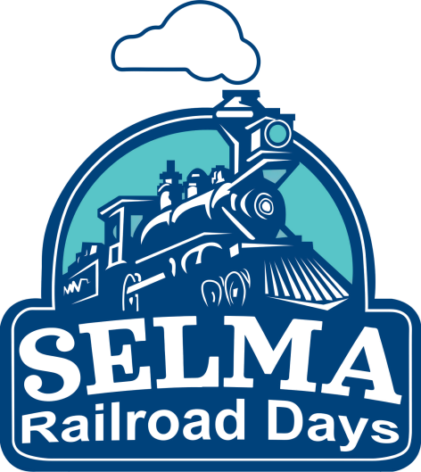
Calling All Railfans Selma Railroad Days
Friday, October 7th-Sunday, October 9th | Downtown Selma
PRESENTED BY Selma Parks and Recreation: The Town of Selma invites you to help us celebrate our town’s history with the railroad. The 47th annual Selma Railroad Days Festival will be held in Downtown Selma, from October 7-9th, 2022. We are looking forward to opportunities to build lasting memories and make this year's festival one to remember. Without the generous support of our local business community, the festival would not be possible. We hope that you will consider partnering with us as a sponsor. We are excited to share with the community the importance of the railroad; our citizens work to preserve the Historic Selma Depot and celebrate the many cultures that now call Selma home. Our committee is excited about the new changes to the event this year. We believe it will create new interest.
WHAT IS Selma Railroad Days:
Selma Railroad Days is a family-friendly event. The event features a wide selection of railroad-themed activities, vendors, a parade, Chew Chew Food Truck Rodeo, Selma Firefighters Association BBQ Cook-Off, TCA Southeastern Train: SETCA model train exhibits, Hispanic American Heritage Festival, the crowning of Miss. Hispanic Heritage Johnston County, Junior Engineer Stations, kid zone, My Kids Club 5K run/walk, and much more! This festival offers 3 Days of fun and interactive activities for all ages.

ADMISSION IS FREE!
Tickets will be available for purchase for inflatables, model train exhibits, etc.
SPONSORSHIP INFORMATION:

LOCOMOTIVE SPONSOR - $15,000 (2)

ENGINEER SPONSOR - $7,500 (3)

Listed as partner organizations presenting the Selma Railroad Days with the Town of Selma in print, billboard, and radio advertisements. Includes premier festival booth (if needed). Selma Railroad Days Parade slot (if wanted). Sponsor acknowledgment in print media. Logo and link on Railroad Days website. Logo on t-shirts. Exclusive naming rights for 1 of the two main stages. Exclusive placement of advertisement on day event signage and social media. Logos on step and repeat festival banner. (10) Complimentary festival t-shirts. Meet and greets with headline bands Friday and Saturday nights. Access to the sponsor's hospitality room during the festival. Live acknowledgment during all concert events.

Includes premier festival booth (if needed). Selma Railroad Days Parade slot (if wanted). Exclusive sponsorship of one segment. Sponsor acknowledgment in print media advertisement. Logo and link on Railroad Days website. Logo on t-shirts. Exclusive placement of advertisement on day of event signage and social media. Meet and greets with headline bands Friday and Saturday nights. Access to sponsor hospitality room during the festival. (8) Complimentary festival t-shirts. Live acknowledgment during all concert events.

CONDUCTOR SPONSOR - $5,000

TRAINMASTER SPONSOR - $2500

FIREMAN SPONSOR - $1,000

STATION MASTER - $500

STATION ATTENDANT - $250

Includes festival booth (if needed). Selma Railroad Days Parade slot (if wanted). Meet and greets with headline bands Friday and Saturday nights. Sponsor acknowledgment in print media advertisement. Logo and link on Railroad Days website. Logo on t-shirts. Exclusive placement of advertisement on day of event signage and social media. Access to the sponsor's hospitality room during the festival. (7) Complimentary festival t-shirts. Live acknowledgment during all concert events.

Includes festival booth (if needed). Selma Railroad Days Parade slot (if wanted). Logo and link on Railroad Days website. Logo printed on the festival t-shirts Exclusive placement of advertisement on day of event signage and social media. Access to the sponsor's hospitality room during the festival. (5) Complimentary festival t-shirts.
Selma Railroad Days parade slot (if wanted). Logo and link on Railroad Days website. Includes name printed on t-shirts. Exclusive placement of advertisement on day of event signage and social media. Access to the sponsor's hospitality room during the festival. (3) Complimentary festival t-shirts.
Includes printed as sponsor on the day of the event and on social media. Name and link on Railroad Days website. Includes name printed as sponsor on the festival t-shirts. Access to the sponsor's hospitality room during the festival. (2) Complimentary festival t-shirts
Includes name printed as sponsor on the day of the event and social media ads. (1) Complimentary festival t-shirts.

Questions? Email Please contact Alyssa Fox, Selma Parks and Recreation Director at afox@selma-nc.com, or by phone at 919-965-9841, ext: 8001.

