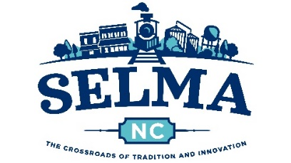

**VOLUNTEER APPLICATION**

To be a Volunteer for the Selma Parks and Recreation Department, you must complete this application. Please PRINT legibly using either blue or black ink.

**PERSONAL INFORMATION**:

FULL LEGAL NAME:

ADDRESS:

STREET CITY STATE ZIP

PHONE: ________________________ EMAIL ADDRESS:

RACE: ­­­­____________ SEX: _____ SS #: ____________________________________ DOB: ­­­­­­________________

Please list any addresses you have had outside of North Carolina in last ten (10) years:

**APPLICANT’S CERTIFICATION, AGREEMENT, WAIVER OF LIABILITY AND RELEASE**:

I hereby certify that all statements on this application are made truthfully and without expansion, and I further understand and agree that such statements may be investigated and if found to be false will be sufficient reason for not being accepted as a Volunteer, or if accepted may result in my dismissal.

I agree to abide by all program rules and regulations set forth by the Selma Parks and Recreation Department. I understand that there are certain inherent risks involved in any activity. I do hereby waive, relinquish, release, discharge and hold harmless the Town of Selma and its employees, volunteers, contributing sponsors and affiliate organizations from any and all liability for any physical or mental injury or aggravation of any pre-existing condition, illness or disability, death, loss of enjoyment or any other harm or loss of any nature which may be sustained by me while serving as a Volunteer for the Selma Parks and Recreation Department.

**APPLICANT’S AUTHORIZATION AND CONSENT FOR RELEASE OF INFORMATION**:

This release and authorization acknowledges that the Town of Selma may now, or at any time while I am volunteering, contact personal references, obtain social security verification, search the sexual offender registry and receive any criminal history record information pertaining to me which may be in the files of any Federal, State or Local criminal justice agency, and to verify any other information deemed necessary to fulfill the job requirements. The results of this verification process will be used to make decisions pursuant to the Town of Selma’s volunteer policies.

I have read and understand this release and consent, and I hereby authorize the background verification. I authorize all persons, organizations and agencies to provide the Town’s designated representative or the Town’s volunteer verification vendor, or its associates with all information that may be requested. I hereby release all of the persons and agencies providing such information from any and all claims and damages connected with their release of any requested information. I agree that any copy of this document is as valid as the original.

I do hereby agree to release and discharge the Town of Selma, the volunteer verification vendor and their associates to the full extent permitted by the law from any claims, damages, losses, liabilities, costs and expenses or any other charge or complaint filed with any agency arising from the retrieving and reporting of information.

Volunteer’s Signature: _____________________________________ Date: __________________

Witness: ________________________________________________ Date: __________________

**THANK YOU SO MUCH FOR YOUR INTEREST IN BEING A VOLUNTEER!**

Please return this completed and signed form to the Town of Selma Finance Building at 114 N. Raiford St. Selma, NC 27576 or email to parks@selma-nc.com