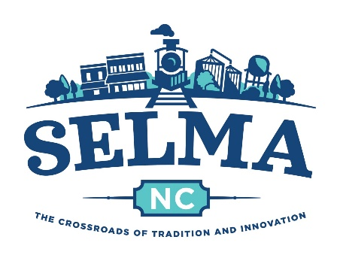**Town of Selma Parks and Recreation Department**

**Code of Conduct**

To ensure a positive and encouraging environment for all, we require that you follow these rules when attending any Selma Parks & Recreation athletic event. Attending an athletic event constitutes as agreeing to abide by the Code of Conduct.

1. **Promote Positive Sportsmanship:** Encourage good sportsmanship for your child and others. Help create a positive and supportive atmosphere so every participant can enjoy the sport they play.
2. **Be a Role Model:** Display respectful behavior at all times. Use appropriate language and gestures and ensure your interactions with players, officials, and parents are always respectful. We understand that sports can be emotional. It is the responsibility of each adult to manage these emotions. Attendees and participants will maintain a sports environment that is free of drugs, tobacco, and alcohol and will refrain from their use at all youth sports events.
3. **Read and Understand League and Sport Rules:** Coaches and parents are required to read and familiarize themselves with all rules and guidelines set forth by the league and Selma Parks & Recreation for their specific sport. This ensures consistency and fair play during games and practices.
4. **Follow Instructions from Parks & Rec Staff:** Parents, coaches, and officials are expected to follow the guidance and instructions of Selma Parks & Recreation staff at all events and practices. Cooperate with any requests or directives they provide to ensure a safe and enjoyable experience for everyone.
5. **No Foul Language or Gestures:** Refrain from using any foul language, gestures, or behavior that could be perceived as offensive or aggressive toward parents, children, coaches, or officials at any time.
6. **Attendance Requirement:** Parents and Coaches are required to attend any meetings called by Selma Parks & Recreation when given at least two business days' notice. If you are unable to attend, it is your responsibility to contact Parks & Recreation staff to obtain the information covered during the meeting. Coaches are expected to attend all games and practices unless given ample notice to Parks & Rec staff.
7. **Focus on Player Development:** Emphasize skill development, teamwork, and a love for the game over winning. The primary goal is to create a positive and enjoyable experience for all players.
8. **Respect for All:** You and your child are expected to treat all participants, coaches, officials, and spectators with respect, regardless of their race, ethnicity, gender, sexual orientation, or abilities. Allow the coaches to coach and instruct the players. Remember only the designated head coach is able to interact with referees and officials during games.
9. **Avoid Unpleasant Interactions:** If you cannot engage kindly with coaches, parents, or fans from the other team you may be asked to leave. Head coaches and Parks & Rec staff have the right to intervene if necessary.
10. **Comply with Ejections:** If an official asks you to leave a game, do so promptly and without causing further disruption.
11. **Report Issues Respectfully:** Any concerns or issues with officials, staff, programs or events should be communicated directly to Selma Parks & Recreation through email at [parks@selma-nc.com](mailto:parks@selma-nc.com). You may be asked to fill out a formal complaint form that is available online. We are here to address concerns constructively.
12. **Represent Selma with Pride:** When wearing Selma team jerseys or official gear and uniforms, remember that you represent our town. Attire and equipment should be maintained with proper care. Remember that wearing Selma jerseys, equipment, and attire means you are representing the Town of Selma. Ensure that jerseys, equipment, and attire are always used respectfully and appropriately.
13. **Social Media Etiquette:** Do not post negative or derogatory comments about other teams, officials, or Selma Parks & Recreation on social media. We ask you to uphold a respectful and positive online presence.

**Acknowledgment and Agreement**

By attending a Selma Parks and Recreation athletic event you agree to adhere to the rules and guidelines outlined above. Failure to comply with this Code of Conduct will result in the removal from games and potential suspension from Selma Parks & Rec athletic events. Refunds will not be issued based on parent suspension.